Table of Contents

1 Concept Paper 1

1.1 Introduction 1

1.2 Background 1

1.3 Description 1

1.4 Key Features 1

1.5 Genre 1

1.6 Concept Map 2

1.7 Platform (optional) 2

1.8 Concept Art (optional) 2

1.9 Market Analysis (optional) 4

2 Functional Specification 5

2.1 Navigation 5

2.2 User Interface (optional) 5

2.3 Storyboards 5

2.4 Media 7

3 Technical Specification (not required for Assignment 2) 8

# Concept Paper

## Introduction

*This report is the task of building a 2D storybook. This e-book can educate children on the principles of independence and has comprehensive functions such as flipping pages, adjusting sound, and helping.*

*Nowadays, parents' education of young children is very important, so my story is mainly about educating them. When I was young, my parents often taught me independence, so I wanted to write a story about independence, which was also my inspiration.*

*Regarding the market situation, with the development of the economy and the popularization of computers and iPads, children and parents have more opportunities to access products such as iPads and computers, and parenting education has also received attention from parents. If it can help parents educate their children while also teaching them how to learn English, it will have a great market advantage.*

## Description

*The main audience of the product is children and their parents.*

*Firstly, those young children (4-9) are too young, and e-books can effectively teach them some principles.*

*Secondly, households with iPads or computers will prioritize e-books as they are more convenient than regular books.*

*Thirdly, for parents who are in a hurry and do not have time to teach their children, e-books can accompany and teach their children when they are busy.*

*Fourthly, for families who want to help their children learn English, e-books have a follow-up function*

*The homepage of the storyboard has a title for the story, as well as buttons for "Start" and volume control. If you click "Start Story", it will start, the concert will automatically play, and a page turning button will appear. When you click the page turning button, you can flip to the previous or next page, and you can adjust the music sound size at any time. And the storyboard can provide reading function.*

*The design of e-books has a good user experience, with clear button positions and a comfortable background color. Simplified Chinese characters with black font color are suitable for children to read. The font is large and does not harm children's eyes. The size of the music sound can be adjusted at any time without harming children's ears. The user experience is very good.*

*Home page: People can clearly see the protagonist of the story, as well as the background. The graphics are very clear, the font is prominent, the button position is appropriate, and the "start" button in the middle is clear, making it easy for people to click. The background music brings a happy atmosphere to people, and the user experience is good.*

*Page1:* *In the green background representing the forest, people can see the cute protagonist, the fox mother and son's conversation, accompanied by warm music, as well as various buttons such as page flipping, returning, etc., which are convenient to use. The warm music makes this family story warm and makes people feel happy.*

*Page2:* *The story is about a little fox leaving home late at night, so a black background can be seen. Coupled with shapes such as the moon and tree owl, people can hear quieter music to highlight the quiet atmosphere at night, bringing users' thinking into the story and providing a good reading experience*

*Page3:* *Here is the story of the little fox arriving in the small town. In the background, you can see the little fox and many houses, as well as many people. Coupled with the lively music and the voices of people speaking, readers can feel the prosperity of the small town, and there are various convenient reading buttons for a great experience.*

*Page4:* *What is said here is the conversation between the little fox and his mother after getting homesick. With the warm music, the children can see the embrace of the mother and son, as well as their conversation, and learn the truth of independence.*

*End page: This is the place to thank the producers, where people can see the names of all participants, and with light music, people can choose to leave from the exit button.*

## Key Features

*Main features: This picture book has a reading function, so children can follow the story picture book and know the pronunciation of words. With the annotations next to the words, they can also understand the meaning of the words, allowing them to learn English while reading the story.*

*Picture books can adjust the font and sound size. If the font is too small during reading, it can harm children's vision. If it is too large, it can affect the visual effect. If the sound is too loud, it may affect children's ears. Therefore, children can choose according to their own situation to protect their vision and hearing.*

*This book also has the sound effect of real book flipping when flipping pages, imitating the reading environment, making children more engaged in reading, deepening their love for books, and cultivating their reading habits.* *At the same time, difficult to recognize characters can also be labeled. Because children still have limited knowledge, it is inevitable that there are unfamiliar words that can be easily understood by children.*

*In this book, there will not be any advertisements appearing because children are too young to distinguish the content of advertisements. In order to avoid negative effects on children, children may click on advertisements due to curiosity, bringing extra consumption to users. To avoid these situations, this is also one of the characteristics.*

*Under limited budget, we need to implement as many practical functions as possible, so first of all, we can provide download caching function. As long as we download in advance, we can watch in a network-free environment. This implementation is quite difficult, but it is very practical and can bring convenience to users, attracting them*

*Secondly, maintaining the ability to adjust fonts and sounds to protect children's vision and hearing is crucial. This implementation difficulty is relatively low and can be solved in terms of technology. If completed, it can also become the main feature that attracts purchases.*

*Thirdly, providing dubbing and reading aloud functions allows children to learn language while reading stories. This is a lower level of difficulty, but requires more budget because we need to hire voice actors, which will bring more expenses.*

*Fourthly, label complex characters, some of which may not be recognized by children, so you can label them. This implementation is relatively difficult and can be solved in terms of technology. If implemented, it can bring convenience to readers and attract them more.*

## Link to GitHub and itch.io (Optional)-*Place your GitHub and/or itch.io links in here if you decide to prototype your designs beyond the documentation. Make sure your GitHub project is public as often the links will not work if the project is set to private.*

GitHub: https://_________________

Itch.io: <https://_________________>

## Theme / Concept Art

*The theme of the story is independence, which tells the story of a little fox who leaves his family and goes to the world outside the forest alone. After an adventure, he safely returns home and eventually learns to be independent. In the process of a child's growth, they cannot rely on their parents for everything, so learning to be independent is very important. This story mainly teaches children how to be independent, and also teaches parents to believe in their children.*

*In terms of conceptual art, the character model is overall round and cute in appearance. Give people a warm and relaxed feeling.*

## Concept Map

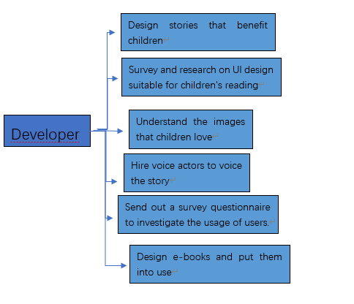

## Evaluation

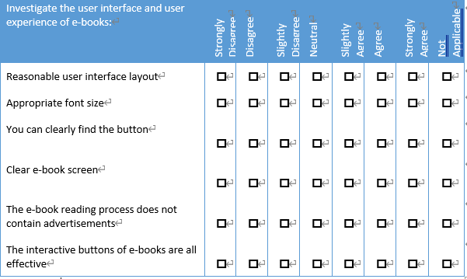

# Functional Specification- 2

## User Interface

Regarding the user interface, the main body of the interface is based on the drawn image. There is a "return" button and menu in the upper left corner, a button to adjust font size and volume in the upper right corner, and a "help" button.

In the middle section, there are forward and backward page flipping buttons on both sides. Below are the reading buttons. Regarding the images of these buttons, the return button is a tilted arrow to the left and up, wrapped in a red button of the same color as the fox skin. And the main body of the animation is mainly in the middle. In many cases, people can see the protagonist of the story, the fox family, and various pictures in the middle, because the background is a forest or a small town, and the background color is mostly green or brown.

The image of the button used to adjust the font is represented by the size letter "a", wrapped in a green button, and the image of the volume icon is a speaker wrapped in a white button. The 'Help' button is a prominent question mark wrapped in red buttons, and the 'Speak' button is annotated with smooth animation. Each button is very obvious and represents a clear function. When your mouse hovers over a button, it will become larger and have a sound effect, clearly informing the user that they have locked the button. The color scheme between the theme and the screen is mainly composed of green, red, and other colors. This style is very relaxed and makes children feel happy. And match with the theme of the background, The image size cannot be too large or too small, as the image is the main body of the screen.

## Storyboards

*[Your storyboards must include all screens, windows and menus (with exception for details placed in the user interface section).*

**Title**: Home Page **Frame ID**: *Home*

**Dimensions-:** **This scene should be as large as possible, as it needs to be easy for the audience to read.**

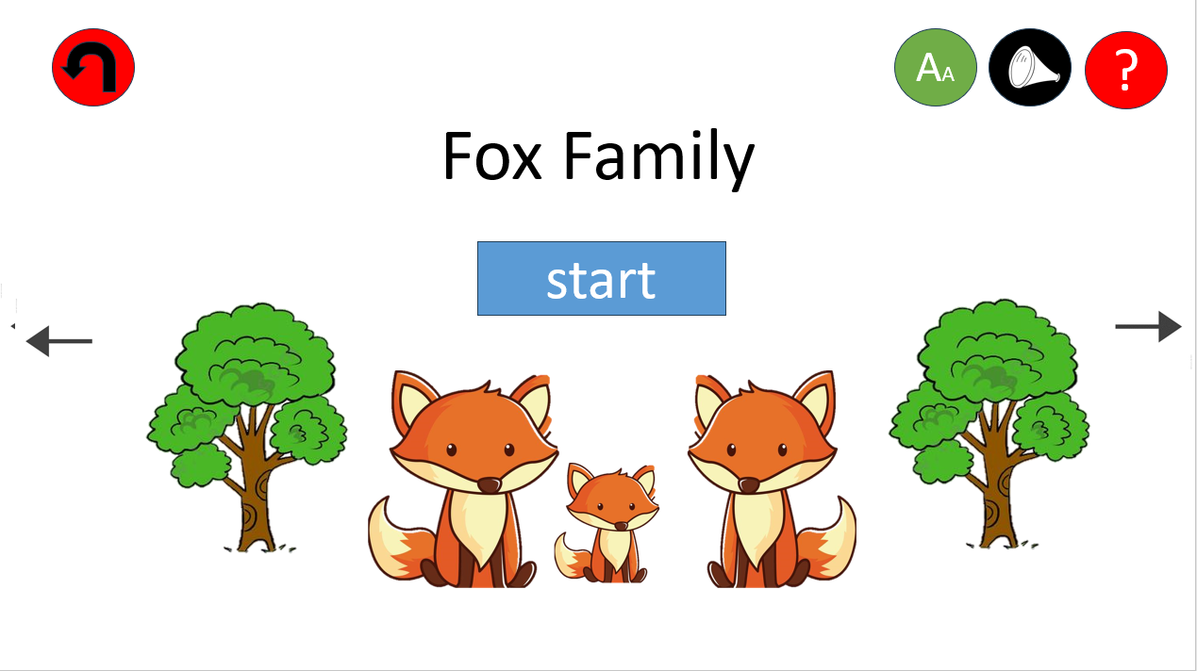

**Media Used**

**Sounds: There are various sounds in the forest**

**Atmosphere: Need a relaxed and pleasant atmosphere**

**Music: cheerful music**

**Onclick: There will be a click sound effect**

**Scene loading: pleasant bird calls**

**Font: Cute Art Characters**

**Images: Trees, Sun, etc**

**Buttons:**

**There is a return button in the upper left corner, buttons for volume, help, font, etc. in the upper right corner, a page flipping button in the middle, and a reading button below**

**Background**:

The initial background was green, gradually showing plants such as trees and grass, and finally the fox family appeared.

**Content:**

**This is the cover of the story and the appearance of the Fox family.**

**Description (purpose / objectives):**

This is the cover of the story and the appearance of the Fox family. When you click on

'start', the story begins.

**Animations:**

Trees will appear

The sun will rise

The Fox Family Appears

**User Interactions Required:**

**Users can enter by clicking the start button, and there are no other mandatory**

**requirements.**

**User Feedback:**

When your mouse hovers over a button, the relevant button will become larger,

indicating that you have hovered. When the mouse hovers, there will be a light sound.

**Navigation / Links:**

**Link to help interface**

**Link to return to homepage**

**Title**: paging **Frame ID**: *paging1*

**Dimensions-:** **This scene should be as large as possible, as it should make the conversation between the fox and the fox's mother obvious.**

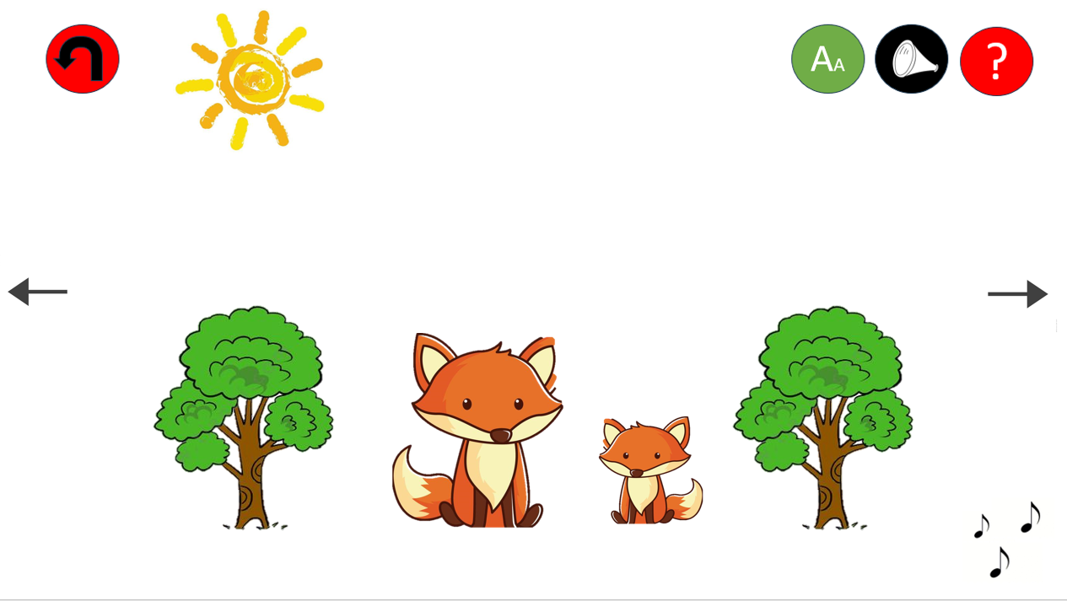

**Media Used: Voice: Dialogue among Foxes**

**Atmosphere: Need a warm atmosphere**

**Music: Warm music**

**Click: there will be a clicking sound effect**

**Scene loading: pleasant bird calls**

**Font: Cute Art Characters**

**Picture: Trees, Sun, Fox Mother and Child**

**Buttons:**

**There is a return button in the upper left corner, buttons for volume, help, font, etc. in the upper right corner, a page flipping button in the middle, and a reading button below**

**Background**:

In the green background, there are many trees, and then the fox mother and son start talking

**Content:**

**This is the first page of the story, which tells the dialogue between the fox mother and son**

**Description (purpose / objectives):**

This is the first page of the story. The fox asked his mother to go out, but she refused.

**Animation:**

Fox mother and son appear

Fox mother and son start a conversation

**User Interactions Required:**

Users can click the button according to their own needs

**User Feedback:**

When your mouse hovers over a button, the relevant button will become larger,

indicating that you have hovered. When the mouse hovers, there will be a light sound.

**Navigation / Links:**

**Link to help interface**

**Link to return to homepage**

**Title**: paging **Frame ID**: *paging2*

**Dimensions-:**

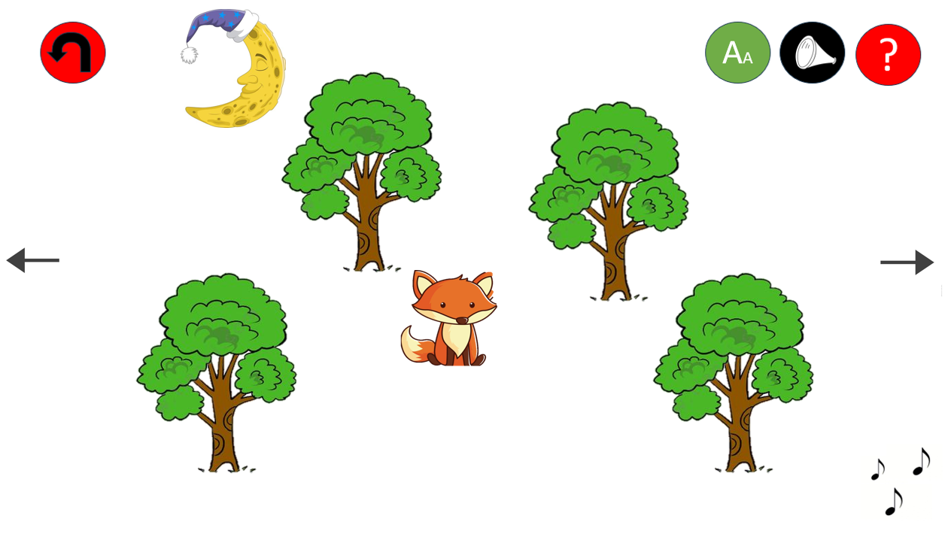

**This scene can be small to highlight the size of the forest**

**Media Used: Sound: The quiet sound of the night, as well as the call of owls**

**Atmosphere: A quiet atmosphere**

**Music: Low pitched music**

**Click: there will be a clicking sound effect**

**Scene loading: Owl chirping**

**Font: Cute Art Characters**

**Image: Trees, Moon, Owl**

**Buttons:**

**There is a return button in the upper left corner, buttons for volume, help, font, etc. in the upper right corner, a page flipping button in the middle, and a reading button below**

**Background**:

The background is dark night, and the fox is on its way at night.

**Conten:**

**This is the second page of the story, which tells the story of a fox secretly leaving home at night**

**Description (purpose / objectives):**

On the second page of the story, after being rejected, the fox secretly leaves at night

**Animations:**

The moon rose

Fox walks quickly

**User Interactions Required:**

Users can click the button according to their own needs

**User Feedback:**

When your mouse hovers over a button, the relevant button will become larger,

indicating that you have hovered. When the mouse hovers, there will be a light sound.

**Navigation / Links:**

**Link to help interface**

**Link to return to homepage**

**Title**: paging **Frame ID**: paging3

**Dimensions-:** **This should be as large as possible, indicating that the fox has arrived in a small town**

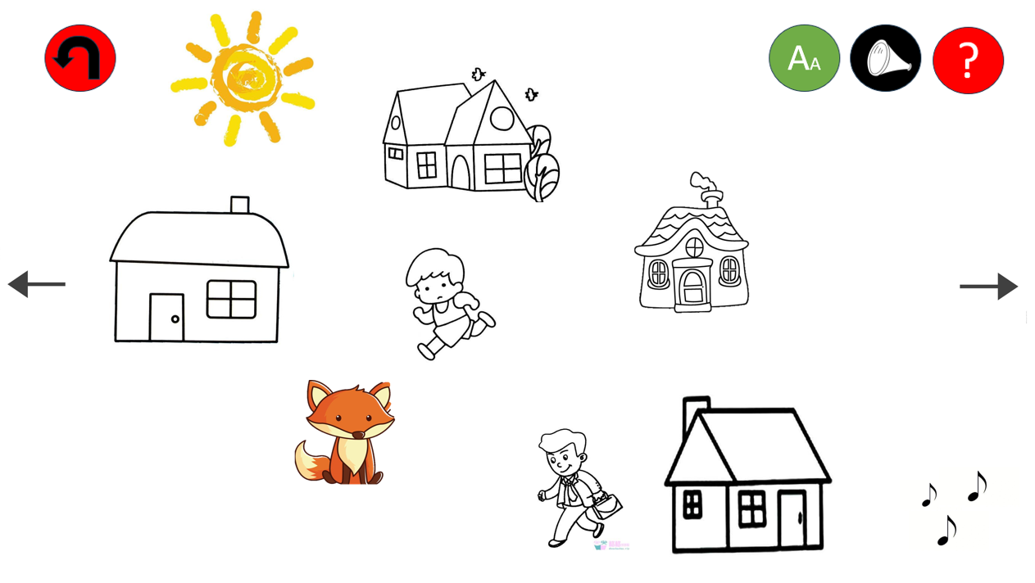

**Media Used-媒体使用: Voice: There are many lively voices in the town**

**Atmosphere: A lively atmosphere**

**Music: slightly complex music**

**Click: there will be a clicking sound effect**

**Scene loading: The voices of people speaking**

**Font: Cute Art Characters**

**Picture: House, People**

**Buttons:**

**There is a return button in the upper left corner, buttons for volume, help, font, etc. in the upper right corner, a page flipping button in the middle, and a reading button below**

**Background**: The background is daytime, and the fox reaches the town

**Content: This is page three, the fox has arrived in the town**

**Description (purpose / objectives):**

This is the third page of the story. After walking at night, the fox has reached the small

town

**Animations:**

People walk and talk

Fox walking

**User Interactions Required:**

Users can click the button according to their own needs

**User Feedback:**

When your mouse hovers over a button, the relevant button will become larger,

indicating that you have hovered. When the mouse hovers, there will be a light sound.

**Navigation / Links:**

**Link to help interface**

**Link to return to homepage**

**Title**: paging **Frame ID**: *paging4*

**Dimensions:** **This scene should be large, highlighting the warm scene of reunion**

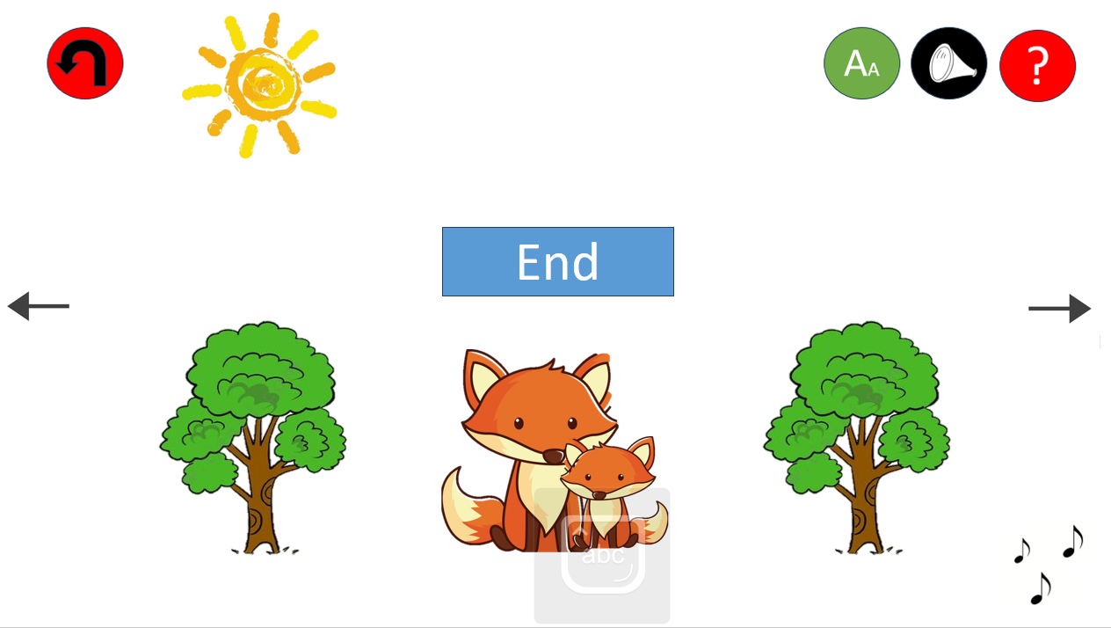

**Media Used:**

**Sound: There are various sounds in the forest**

**Atmosphere: Need a warm atmosphere**

**Music: Warm music**

**Click: there will be a clicking sound effect**

**Scene loading: pleasant bird calls**

**Font: Cute Art Characters**

**Images: Trees, Sun, etc**

**Buttons: There is a return button in the upper left corner, buttons for volume, help, font, etc. in the upper right corner, a page flipping button in the middle, and a reading button below**

**Background**:

The fox went home after homesickness and reunited with his mother.

**Content:**

**After the fox returned home, he reunited with his mother and had a conversation, saying that he had grown up**

**Description (purpose / objectives):**

After the fox returned home, he reunited with his mother and had a conversation,

saying that he had grown up, and his mother also said that he had grown up

**Animations:**

Fox Mother Child Dialogue

Fox mother and son embrace

**User Interactions Required:**

Users can click the button according to their own needs

**User Feedback:**

When your mouse hovers over a button, the relevant button will become larger,

indicating that you have hovered. When the mouse hovers, there will be a light sound.

**Navigation / Links:**

**Link to help interface**

**Link to return to homepage**

**Title**: Last Page **Frame ID**: *Last Page*

**Dimensions-:This page is moderate and a list of developers appears**

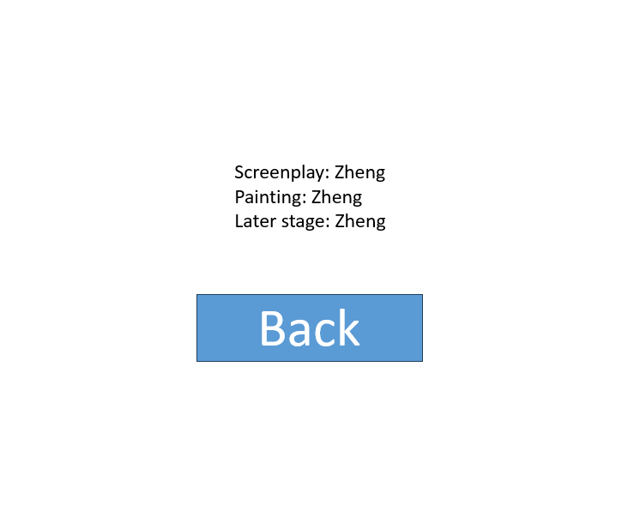 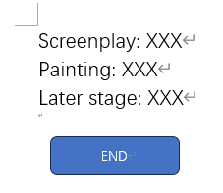

**Media Used:**

**Sound: Low pitched music**

**Atmosphere: A simple expression of gratitude atmosphere**

**Music: Bass music**

**Click: No other special effects after exiting**

**Scenario loading: returning to the homepage**

**Font: Cute Art Characters**

**Image: Developer Name**

**Buttons: Only one exit button**

**Background**: Black background highlights the name

**Content: Developer List**

**Description (purpose / objectives):**

:Thank you to the developer

**Animations:** **Gradually emerging developer list**

**User Interactions Required:**

Users can click the button according to their own needs

**User Feedback:**

Click the exit button to exit without any additional special effects.

**Navigation / Links:**

**Link back to homepage**

## Media

*The button is self-made by me*

|  |  |
| --- | --- |
| Image name or description | Resource address/URL |
| Fox Image | https://image.baidu.com/search/index?tn=baiduimage&ipn=r&ct=201326592&cl=2&lm=-1&st=-1&fm=result&fr=&sf=1&fmq=1695899345472_R&pv=&ic=&nc=1&z=&hd=&latest=&copyright=&se=1&showtab=0&fb=0&width=&height=&face=0&istype=2&dyTabStr=MTEsMCwyLDMsMSw2LDQsNSw4LDcsOQ%3D%3D&ie=utf-8&sid=&word=%E7%8B%90%E7%8B%B8%E7%AE%80%E7%AC%94%E7%94%BB |
| Tree image | https://image.baidu.com/search/index?tn=baiduimage&ipn=r&ct=201326592&cl=2&lm=-1&st=-1&fm=result&fr=&sf=1&fmq=1695899405191_R&pv=&ic=&nc=1&z=&hd=&latest=&copyright=&se=1&showtab=0&fb=0&width=&height=&face=0&istype=2&dyTabStr=MTEsMCwyLDMsMSw2LDQsNSw4LDcsOQ%3D%3D&ie=utf-8&sid=&word=%E6%A0%91%E7%AE%80%E7%AC%94%E7%94%BB |
| Sun  image | https://image.baidu.com/search/index?tn=baiduimage&ipn=r&ct=201326592&cl=2&lm=-1&st=-1&fm=result&fr=&sf=1&fmq=1695899501682_R&pv=&ic=&nc=1&z=&hd=&latest=&copyright=&se=1&showtab=0&fb=0&width=&height=&face=0&istype=2&dyTabStr=MTEsMCwyLDMsMSw2LDQsNSw4LDcsOQ%3D%3D&ie=utf-8&sid=&word=%E5%A4%AA%E9%98%B3%E7%AE%80%E7%AC%94%E7%94%BB |
| Moon  image | https://image.baidu.com/search/index?tn=baiduimage&ipn=r&ct=201326592&cl=2&lm=-1&st=-1&fm=result&fr=&sf=1&fmq=1695899516472_R&pv=&ic=&nc=1&z=&hd=&latest=&copyright=&se=1&showtab=0&fb=0&width=&height=&face=0&istype=2&dyTabStr=MTEsMCwyLDMsMSw2LDQsNSw4LDcsOQ%3D%3D&ie=utf-8&sid=&word=%E6%9C%88%E4%BA%AE%E7%AE%80%E7%AC%94%E7%94%BB |
| People  image | https://image.baidu.com/search/index?tn=baiduimage&ipn=r&ct=201326592&cl=2&lm=-1&st=-1&fm=result&fr=&sf=1&fmq=1695899527015_R&pv=&ic=&nc=1&z=&hd=&latest=&copyright=&se=1&showtab=0&fb=0&width=&height=&face=0&istype=2&dyTabStr=MTEsMCwyLDMsMSw2LDQsNSw4LDcsOQ%3D%3D&ie=utf-8&sid=&word=%E4%BA%BA%E7%AE%80%E7%AC%94%E7%94%BB |
| House image | https://image.baidu.com/search/index?tn=baiduimage&ipn=r&ct=201326592&cl=2&lm=-1&st=-1&fm=result&fr=&sf=1&fmq=1695899536909_R&pv=&ic=&nc=1&z=&hd=&latest=&copyright=&se=1&showtab=0&fb=0&width=&height=&face=0&istype=2&dyTabStr=MTEsMCwyLDMsMSw2LDQsNSw4LDcsOQ%3D%3D&ie=utf-8&sid=&word=%E6%88%BF%E5%AD%90%E7%AE%80%E7%AC%94%E7%94%BB |